#### **Title:** Shifts in fine root traits within and among species along a small-scale hydrological gradient

**Authors:** Guy M. Taseski1, David A. Keith2, Rhiannon L. Dalrymple1, and William K. Cornwell1

**Author affiliations:**

1. Evolution & Ecology Research Centre, School of Biological, Earth and Environmental Sciences, UNSW Sydney, Sydney, NSW, Australia 2052
2. Centre for Ecosystem Science, School of Biological, Earth and Environmental Sciences, UNSW Sydney, Sydney, NSW, Australia 2052

**Corresponding Author email:** rhiannon.dalrymple@gmail.com

**Corresponding author telephone:** +61 412 828 914

**Keywords:** fine root traits, plant traits, hydrological gradient, soil moisture, root density

**Abstract**

*Background and Aims*: Lessons from above-ground trait ecology and resource economics theory may not be directly translatable to below-ground traits due to differences in function, trade-offs and environmental constraints. Here we ask whether correlations among above-ground and below-ground plant traits conform with predictions from resource-economic spectrum theory; and if root functional traits vary along a small-scale hydrologic gradient in the same manner as above-ground functional traits.

*Methods*: We sampled four below-ground, fine-root traits (specific root length, branching intensity, root tissue density and root dry mass content) and four above-ground traits (specific leaf area, leaf size, plant height and leaf dry mass content) in vascular plants along a fine-scale hydrological gradient within an upland wetland community in southeastern Australia. Belowground traits were sampled both within and among species.

* *‘Key Results*: Eight of 28 trait-trait pairs were significantly correlated, with five of these significant correlations following expectations derived from resource economic theory. Root traits shifted both within and among species across the hydrological gradient, with individual and species with low root density and low root dry matter content excluded from drier microhabitats. Leaf dry-matter content and plant height varied across the gradient, with plant species occupying drier sites being taller and having lower leaf water content both within and across species.
* *Conclusions*: One of the challenges of research on root traits has been intraspecific variation. Here we show that part of this variation is structured by small-scale hydrological gradients, and this structure aligns with among species trends. Given the importance of roots in the uptake of resources, and in carbon and nutrient turnover, it is vital that we establish patterns of root trait variation across environmental gradients.

# **Introduction**

The expression of plant functional traits varies across environmental gradients, reflecting the ecological strategies that are viable or adaptive in particular conditions (Lavorel and Garnier 2002; Moles 2018; Violle et al. 2007). Traits have been shown to vary across broad, macro-ecological gradients such as across regions or latitudes (Moles et al. 2007; Moles et al. 2011; Moles et al. 2009; Wright et al. 2017; Wright et al. 2001) and also across small-scale environmental gradients and microsites within habitats and communities (Ackerly and Cornwell 2007; Cornwell and Ackerly 2009; Kraft and Ackerly 2010). Water availability, which is one of the major environmental filters shaping plant strategies (Cornwell and Ackerly 2009; Keddy 1992; Reich 2014; Wright et al. 2004), is a key driver of trait variation at both of these scales (Araya et al. 2011; Letten et al. 2015; Silvertown et al. 2015).

The majority of trait ecology focuses on a few key above-ground traits with well-known connections to plant growth and life history (Díaz et al. 2016; Moles et al. 2014; Reich et al. 2003). Plant resource economics are fully developed for certain above-ground traits (Chave et al. 2009; Reich et al. 1997; Wright et al. 2004); for instance, large, low LMA leaves tend to be found in environments with greater availability of macro-nutrients, and plants tend to be taller where precipitation is higher (Moles et al. 2014; Wright et al. 2004). However, lessons from above-ground trait ecology may not be directly translatable to root traits as below-ground organs have functions other than resource uptake including physical support, and they experience different environmental constraints and trade-offs related to, for example, oxygen availability, physical soil material, and spatially structured nutrients (Kramer‐Walter et al. 2016; Reich 2014; Weemstra et al. 2016). Given the importance of roots in the uptake of resources from the soil, including water, establishing patterns of root trait variation across environmental gradients is a vital frontier of plant ecology (Holdaway et al. 2011; Laliberté 2017).

Despite the importance of roots, the below-ground dimension of plant trait variation is woefully understudied (Laliberté 2017; McCormack et al. 2015; Weemstra et al. 2016). This is partly for pragmatic reasons as below-ground traits are more difficult to access, observe and sample and thus there is considerably less data available for root traits, especially for fine roots (see figure in (Laliberté 2017)). Root systems have also been shown to be highly plastic in their morphology/architecture and overall investment in biomass in response to variation in the spatial and temporal availability of nutrients and water encountered by individual plants (Deak and Malamy 2005; Freschet et al. 2015; López-Bucio et al. 2003; Wang et al. 2006). Such plasticity adds difficulty to the determination of general ecological and economic patterns in below-ground trait at inter- and intraspecific levels in the same manner as above ground traits, as it may alter trait relationships or biotic interactions across environmental gradients (Freschet et al. 2013). A full understanding of variation in plant functional traits demands exploration of both intra- and interspecific variation, as even though predictions for trait changes across gradients may be the same within and across species, the mechanisms shaping that variation will differ (REF). Further, while greenhouse based studies have demonstrated interesting trends in below-ground trait variation across tightly controlled resource gradients (e.g. Freschet et al. 2015), there has been limited extrapolation to the field where the challenges due to multiple drivers of variation and due to difficultly of observation mount. Thus, the current work seeks to contribute to understanding of in situ variation in below-ground traits both within and across species, and the applicability of trait correlation predictions derived from resource economics.

Fine roots are non-woody, ephemeral, absorptive structures primarily responsible for the uptake of water and nutrients; fine roots also mediate ecosystem carbon cycling through exudation of carbon below-ground and through root turnover (see McCormack et al. 2015). As fine roots are resource acquisition structures and can thus be thought of as analogs to leaves, fine root traits may be expected to reflect trade-offs between different environmental or physical constraints culminating in ecological strategies for rooting. These strategies may in turn reflect resource economics, similar to those known for the leaf economic spectrum (LES). It is established that resource acquisitive (or “fast”; as opposed to resource conservative, or “slow” (as per Reich 2014)) plant species tend to have large, low density leaves (i.e. high specific leaf area (SLA)) that can be highly productive resource accumulators with rapid return on investment (Reich et al. 1997; Wright et al. 2004). Conservative species, on the other hand, may tend to invest in smaller, denser, more heavily constructed leaves that last for longer but that provide a slower return on the investment. Thus, LMA (the inverse of SLA) and leaf dry-matter content tend to be positively correlated with leaf size. If we consider specific root length (SRL; the length of fine root tissue per given mass, i.e. area per mass) of fine roots is an analogous resource acquisition trait to SLA, and consider fine root branching intensity to be analogous with leaf area (as it is related to the size of area that resource acquisition tissue is divided into), then we expect resource acquisitive species to have high SRL, high branching intensity, and low root tissue density and dry-matter content (Weemstra et al. 2016). Thus, we would expect SRL to be positively correlated with the density and dry-matter content of roots, and negatively correlated with root branching intensity. Our first aim was to determine if these correlations predicted by a whole plant economic spectrum framework (sensu Reich 2014) are evident in trait correlations across species within an upland wetland community. Some strong correlations between fine root traits have been demonstrated (Eissenstat et al. 2015; Holdaway et al. 2011), however, evidence for the existence of a root economic spectrum is not as consistent as that supporting the LES (see review in Reich 2014), and may hold better in herbaceous than in woody species (Roumet et al. 2016; Weemstra et al. 2016).

The second aim of the present work was to establish how above-ground and fine root traits vary across a small scale hydrologic gradient, both within and across species. In plant communities, shifts in traits across gradients occur either due to a shift in the community assembly process leading to species turnover or shifts within species or a combination of both processes (Cornwell and Ackerly 2009). Silvertown et al. (1999) showed that species segregate along a soil moisture gradient within a European wet meadow community and postulated that the mechanism was related to tolerance of aeration and drying stress. Araya et al. (2011) and Letten et al. (2015) also similarly found that different species had different optimal positions along hydrological gradients with Fynbos and heathland communities, respectively. Only a few studies have considered how fine roots vary across environmental gradients and whether they are influenced by the same trade-offs as found in above-ground plant organs (Holdaway et al. 2011; Kramer‐Walter et al. 2016; Valverde‐Barrantes et al. 2013). Specific root length has been mostly examined along fertility and temperature gradients (Holdaway et al. 2011; Zadworny et al. 2016) with only a few studies conducted along a hydrological gradient, which found it to increase in areas of flooding (Thorne & Frank 2009; Shi et al. 2015). Based on resource economic theory, we expect that high SRL, high branching intensity and low tissue density and root dry-matter content would tend to be found in microhabitats with greater water availability, all else being equal. As soil moisture levels increase, there is also a tipping point where oxygen becomes more limiting than water, and a non-linear response of SRL to the moisture gradient may be expected. In either case, we expect to see such shifts in trait values, both within and across species, along fine-scale hydrological gradient as evidence of environmental filtering (Ackerly and Cornwell 2007; Cornwell and Ackerly 2009; Savage and Cavender-Bares 2012). Given that soil properties can vary markedly over small distances, exploring patterns in traits across fine-scale gradients will help determine whether variation at this level could be masking patterns at larger scales.

The aims of this study are to determine whether:

1. correlations among above-ground and below-ground plant traits conform with predictions from resource-economic spectrum theory; and
2. root functional traits vary along a small-scale hydrologic gradient in the same manner as above-ground functional traits following prediction from by resource-economic spectrum theory

To answer these questions, we sampled four below-ground, fine-root traits (specific root length (SRL), branching intensity, root tissue density (RTD) and root dry mass content (RDMC)) and four above-ground traits (specific leaf area (SLA), leaf size, plant height and leaf dry mass content (LDMC)) in vascular plants along a fine-scale hydrological gradient within an upland wetland community in southeastern Australia.

# **Materials and methods**

The study was conducted in an area of wet heathland vegetation within the Royal National Park, New South Wales, Australia (34° 5'43.22"S, 151° 9'9.97"E) in May 2016 to January 2017. The site is within the study area of Letten et al.(2015) on a local soil moisture gradient, which marks a transition between two vegetation classes known as Sydney Coastal Heaths on drier soils and Coastal Heath Swamps on wetter soils (Keith 2004). Both communities are comprised of sclerophyllous woody shrub layer and an herbaceous ground layer (denser in heath swamp), with species in the Proteaceae, Ericaceae, Myrtaceae, Fabaceae, Restionaceae, Poaceae and Cyperaceae dominant throughout (Keith, 2004). The soils are sandy loams derived from sandstone, acidic and low in nutrient concentrations (Keith and Myerscough 1993). Parts of the site were subjected to low intensity burns in 2015 and in 1994. We sampled patches with different fire histories in order to control for some of the variation that may be induced by these events.

We established eighteen 10- by 10-m plots across the hydrological gradient within our target vegetation community. Four of the eighteen plots were situated along the wettest area of the gradient, with two of those plots placed in patches last burnt in 2015 and two in patches last burnt in 1994. Another four plots were placed along the driest area of the gradient, with two placed in patches burnt in 2015 and two in 1994. The remaining ten plots locations were placed randomly across the hydrological gradient and divided evenly between vegetation patches with 2015 and 1994 fire histories. We focused our sampling efforts on non-woody species which Letten et al. (2015) demonstrated were most frequently encountered across the hydrological gradient in this area. We have excluded two species sampled by Letten et al. (2015): *Cassytha glabella,* as it has a climbing parasitic habit and loses its roots in adulthood, and *Xanthorrhoea resinosa,* as there were logistic difficulties in capturing its deep, contractile roots. To capture some of the variation between woody and non-woody species, we also sampled some species of perennial shrubs which were excluded from Letten’s *et al.* (2015) study. In total, we sampled 21 of the most abundant species from across the hydrological gradient.

## *Soil Moisture sampling*

We measured the soil moisture for our plots using five randomly placed 10-cm-deep cores taken during May, 2016. Each individual soil core was placed in a zip lock bag and placed in a climate-controlled chiller box and processed within 48 hours. Because of frequent fluctuations in water levels at the site (see Letten et al. 2015) we sought an estimate of the long-term soil moisture by measuring the proportion of soil organic matter (SOM) using a Loss on ignition technique (Ball 1964). SOM is a measure of moisture retention potential (Manns et al. 2016) and reflects reduced microbial activity (and hence lower organic decomposition rates) when soil pores are frequently filled with water, limiting oxygen for microbial respiration. Samples were dried at 105 °C overnight in a drying oven, after which a 5-gram subsample from each soil sample was placed into ceramic crucibles. These subsamples were weighed, fired in a pre-heated muffle furnace at 375 °C for 16 hours, and then placed into a desiccator for 30 minutes before being weighed again. The percentage SOM content of the soil samples was calculated as the difference in pre-ignition and post-ignition weight divided by the pre-ignition weight.

## *Functional trait sampling*

The four above-ground traits measured were leaf size (mm2), specific leaf area (SLA; m2 kg-1), plant height (m) and leaf dry-matter content (LDMC; mg g-1) following (Pérez-Harguindeguy et al. 2013). These traits were chosen based on connection to key functions (Díaz et al. 2016; Garnier et al. 2016). For each species, these traits were measured on three individuals randomly selected from each of the quadrats, sampling at least three leaves on each individual for leaf traits.

The four fine root traits measured were root branching intensity (RBI; tips cm-1), specific root length (SRL; m g-1), root tissue density (RTD; mg mm-3) and root dry-matter content (RDMC; mg g-1). These traits were chosen to enable comparison of results to those of Kramer-Walter et al (2016) which explored variation in fine root traits across soil fertility gradients. At each of our quadrats, we measured these four fine root traits on up to three randomly selected individuals of each target species present in the plot, amounting to a total of 490 root samples. Fine roots are defined as first and second order roots less than 0.2mm in width (McCormack et al. 2015). Root samples were extracted using shovels and mattocks to excavate around the roots and remove them from the soil taking care that soil was not forcefully removed so to reduced damage and stress. For larger woody perennial species, we dug around the stem until hitting a lateral root, then we carefully excavated the entire root length until reaching the first order fine roots. All samples were placed in zip-lock bags and stored in a chilled, dark container for transport. In the laboratory, roots were first cleaned in running water and small particulates bound to the roots were delicately removed from the root mass.

One sub-section of fine roots was used to calculate SRL (following Pérez-Harguindeguy et al. 2013) and RBI (following Kramer‐Walter et al. 2016). The subsection was digitally scanned using a CanoScan LiDE 100 flatbed scanners set at 600 dpi. To prevent root overlap, roots were suspended in water on transparency film and surrounded by a lip of plasticine. A 1 cm scale bar was placed beside all specimens to enable measurement of total root length using the software ImageJ. After the roots were scanned, they were placed in a paper bag and dried over 48 hours at 60 °C in a drying oven before being weighed. Total root length and dry mass data were used to calculate specific root length (SRL) and root branching intensity (RBI). SRL was calculated as the total length of all the fresh first and second order roots divided by its dry mass (m g-1). RBI was calculated as the number of root tips divided by the total root length in centimetres (tips cm-1).

A second sub-section of fine roots was used to determine root tissue density (RTD) and root dry-matter content (RDMC). The fresh mass of the sub-section measured on a balance to 3 dp (mg). Root volume was determined using a pycnometer, with the difference between the pycnometer with and without roots plus the mass of the fine roots divided by the density of the water equalling the volume of the roots .(Jensen et al. 1969) The fine root sample was then placed in a paper envelope and dried over 48 hours at 60°C in a drying oven. The information determined from this was used to calculate RTD and RDMC. RTD was calculated as the dry mass / root volume (mg mm-3). RDMC was calculated as dry mass / fresh mass (mg g-1).

## 

## *Statistical analysis*

We derived Pearson rank correlation coefficients between mean values per species for all pairwise combinations of our eight plant traits to determine the patterns of significant correlations and compare them to the expectations of the root and leaf economic spectrums. Our main results are presented without correction for multiple testing. However, as we determined 28 trait-trait correlations, we have also indicated which correlations remain significant after Bonferroni correction.

We used linear models to establish whether above-ground and fine-root traits varied across species along the hydrological gradient (soil moisture potential represented by SOM). Leaf trait variation across the hydrological gradient was assessed at an across species level using species trait means.

For root traits, we explored the variation across the gradient with increasing levels of model complexity. We started with the simplest of models, across species trait means. Second, we ran the same model including the within species variation. Then, we included species as a random effect. Finally, we allowed species to exhibit different slopes. These four models were compared using AIC values in order to establish if patterns along the gradient are explained by variation within species, between species, or both.

All statistical analyses were conducted in R version 3.6.0.

# **Results**

Between our four above-ground and four below-ground traits there were eight trait-trait pairs that were significantly correlated. The direction of five significant correlations follow expectations derived from trait resource economic theory: Root dry matter content was significantly positively correlated with root density (correlation coefficient (CC)= 0.88; P < 0.001), with leaf mass per area (CC = 0.42; P = 0.047) and with leaf dry matter content CC 0.59; P = 0.004); Leaf mass per area was also significantly positively correlated with leaf dry matter content (CC = 0.51; P = 0.016), as was leaf area with plant height (CC = 0.44; P = 0.040). The direction of three significant correlations goes against expectations derived from resource economic theory: Root branching intensity was positively correlated with leaf dry matter content (CC = 0.48; P = 0.022), and with leaf mass per area (CC = 0.65; P = 0.016); Additionally, leaf area and specific root length were significantly negatively correlated (CC = -0.45; P = 0.034). Using strict Bonferroni correction (alpha = 0.0018) two correlations were significant, the link between RDMC and root density and the link between root branching intensity and LMA.

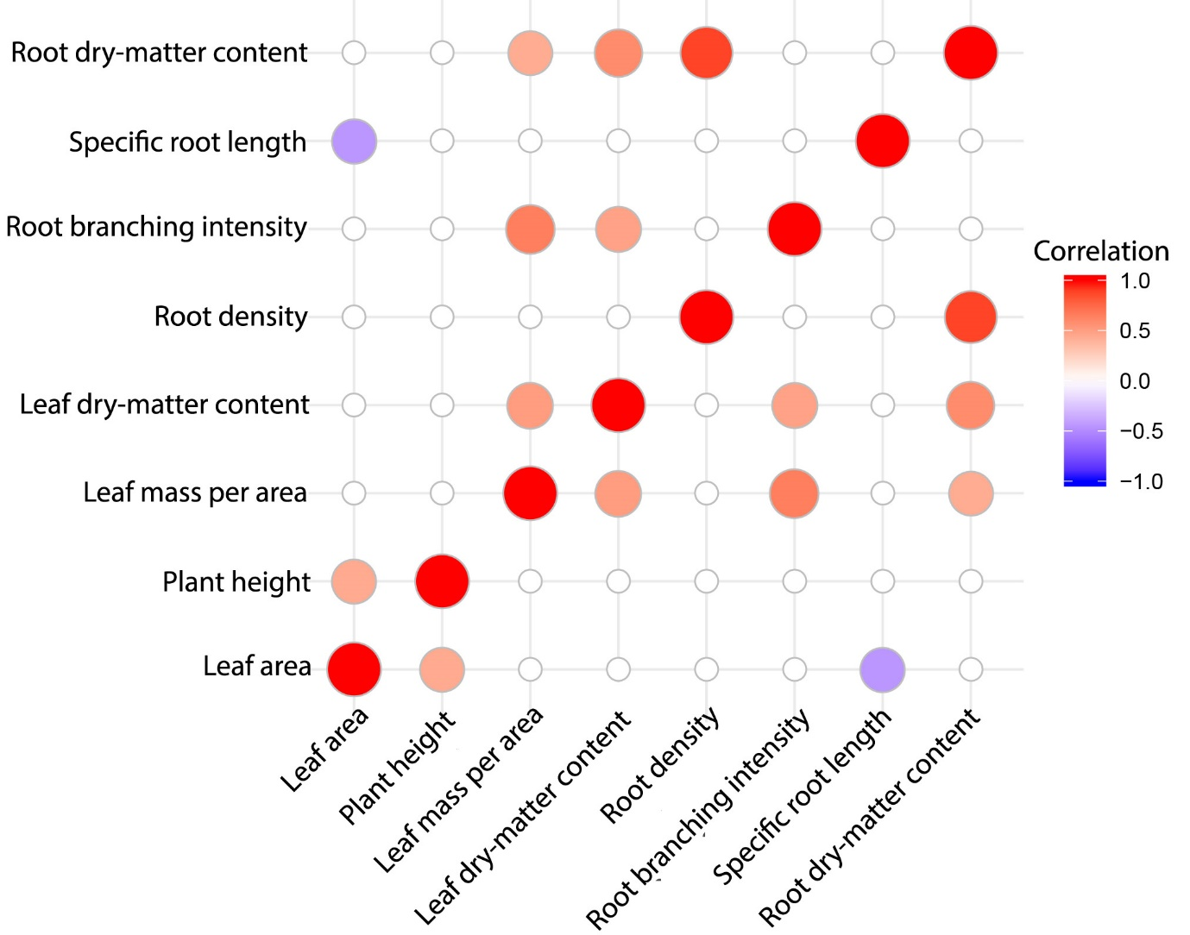

**Figure 1:** Trait correlation matrix between four above-ground and four below-ground traits. Coloured circles indicate significant correlations at α = 0.05, with the colour intensity indicating the correlation coefficient values which range between -1 and 1.

Leaf dry-matter content and plant height varied across the hydrological gradient (P < 0.001 and P = 0.041, respectively), both demonstrating lower trait values at higher SOM content. That is, the plant species occupying drier microhabitats are taller and have lower water content in their leaves.

**Table 1:** Above-ground traits across a small-scale hydrological gradient; only two of four traits varied significantly with SOM

|  |  |  |  |
| --- | --- | --- | --- |
|  | **R2** | **P value** | **Direction of slope** |
| **Leaf dry-matter content** | 0.0524 | <0.001 | Negative |
| **Leaf mass per area** | 0.00532 | 0.102 | - |
| **Leaf size** | 0.00514 | 0.108 | - |
| **Plant height** | 0.00828 | 0.0412 | Negative |

Root density and RDMC vary significantly across a gradient of SOM, both demonstrating lower trait values at site with higher SOM (Table 1).

For root density, the model with the lowest AIC included species as a random effect – that is, the best model included within species variation and allowed species to vary in their intercept (Figure 2). This model explained 49.9 % of the variation in root density (Table 2).

For RDMC, the model with the lowest AIC included the variation within species (Figure 2), explaining 38.2 % of the variation in this trait. However, the model that included species as a random effect was only 1 AIC point higher (and thus the two may not be considered statistically distinguishable (Burnham 2002))(Table 2).

There was no significant trend in root branching intensity evident across species along our hydrological gradient (Figure 2). However, the best model for this trait is that which includes within species variation and allows species to vary in their intercept, explaining 17 % of the variation (Table 2). That is, while there is a trend across species in this trait, an effect of the gradient is evident within species, with individuals in drier sites exhibiting a lower degree of branching than individuals at wetter sites.

Specific root length also did not significantly vary across species with SOM at this scale (Figure 2). Again, the best model for this trait is that which includes within species variation and allows species to vary in their intercept, explaining 14.6 % of the variation. However, this model was only 1 AIC point lower than the model that included only within-species variation (thus may not be considered statistically distinguishable) (Table 2).

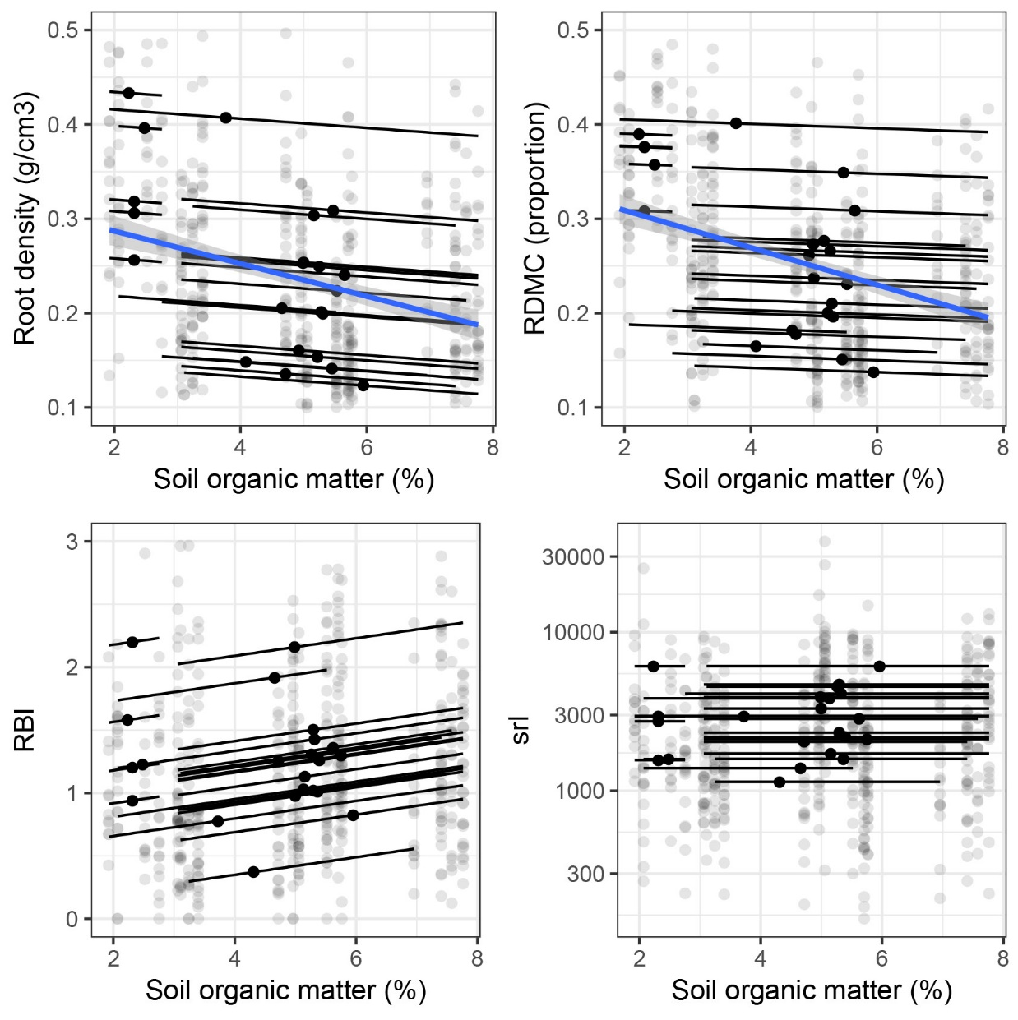

**Figure 2**: Fine root traits across a small scale, hydrological gradient. At the across-species level, significant changes in root density and RDMC are indicated across the gradient in SOM matter (indicative of soil moisture potential) with blue regression lines. Trends in within-species variation are indicated by black regression lines; no significant within species variation was indicated for specific root length (hence, lines have slope of 0).

**Table 2**: Linear models on variation in fine-root traits across a hydrological gradient (measured as SOM).

|  |  |  |  |  |
| --- | --- | --- | --- | --- |
| **Trait** | **Model specification** | **R2** | **AIC** | **P-value effect of SOM** |
| Root Density | only SOM as predictor | 0.0705 | -747 | <0.0001 |
| species only | 0.495 | -991 | <0.0001 |
| SOM + species intercepts | 0.499 | -993 | <0.0001 |
| SOM + species intercepts + slopes | 0.527 | -978 | <0.0001 |
| Root dry-matter content | only SOM as predictor | 0.0486 | -650 | <0.0001 |
| species only | 0.382 | -812 | <0.0001 |
| SOM + species intercepts | 0.383 | -811 | <0.0001 |
| SOM + species intercepts + slopes | 0.421 | -798 | <0.0001 |
| Specific root length | only SOM as predictor | 0.00708 | 9350 | 0.0630 |
| species only | 0.141 | 9319 | <0.0001 |
| SOM + species intercepts | 0.146 | 9318 | <0.0001 |
| SOM + species intercepts + slopes | 0.176 | 9342 | <0.0001 |
| Root branching intensity | only SOM as predictor | 0.00539 | 1318 | 0.1050 |
| species only | 0.157 | 1277 | <0.0001 |
| SOM + species intercepts | 0.17 | 1271 | <0.0001 |
| SOM + species intercepts + slopes | 0.204 | 1293 | <0.0001 |

# **Discussion**

We have here shown significant variation in below-ground traits at both the intra- and interspecific level across a small-scale hydrological gradient. Root tissue density and RDMC appear to be crucial in the filtering of species across hydrological gradients at small-scales. Additionally, our results provide further evidence that expectations derived from a resource economic spectrum framework do not always hold for below-ground traits.

Root tissue density follows our expectations for resource acquisition and conservation strategies: both within and across species, fine roots are denser at drier sites. Root dry-matter content closely trends the same way. That is, species with low root density and dry-matter content — those species with soft, spongey roots — are filtered out of the community in drier microhabitats. The wetland specialist species that are not found in drier sites in this community are watermilfoil herbs, cordrushes and sedges most commonly found in swamps or in damp or poorly drained soils: *Gonocarpus micranthus, Eurychorda complanata, Plinthanthesis paradoxa, Caustis pentandra, Lepyrodia scariosa,* and *Leptocarpus tenax.* The failure of the low root tissue density species to extend their range to dry sites could be due to greater desiccation susceptibility of the roots, or because of links of these root traits to whole plant drought tolerance traits (see Hacke et al. 2001). The converse is not true – the species with the highest values of root density are not filtered out of the community as soils become wetter. While species inhabiting drier soils appear to have broad soil moisture niches, it may not be possible for a species with low root density to persist in dry soils — and low root density may instead be a key trait of wetland specialist species. We suggest that it is these root traits — root tissue density and RDMC — that underpin the mechanism that drives species turnover across this hydrological gradient. These traits may hold great potential for increasing predictive power in the explanation of species distributions.

There was no evidence of environmental filtering in either root branching intensity or specific root length in this system, at this scale. There was, however, evidence that the within species variation in root branching intensity does follow predictions in line with RES. That root density, but not SRL shows the pattern expected from resource economic theory, suggests a decoupling of the cost of building the tissue--root tissue density--from instantaneous absorptive capacity--SRL. This differs from current theory for leaves where nutrient acquisition has been shown to be negatively correlated with traits that confer long tissue lifespan (Wright et al. 2004; Reich 2014). SRL is a commonly studied root trait because of the theoretical analogy to SLA. SRL has been shown to be positively correlated with increased flooding within a species in Argentina (Rubio et al. 1997) and among species in China (Shi et al. 2015), and high SRL may be capable of absorbing greater quantities of water (Withington et al. 2006; Comas et al. 2012). That we did not see significant variation in SRL across a hydrology gradient – either within or across species – and that we did not see correlation between SRL and SLA supports the findings of (Freschet et al. 2013; Freschet et al. 2015) and suggests that we should reconsider our use of SRL as a below ground indicator of SLA. SRL does not appear to be as important or as related to resource economics in the same way as SLA, and it may be highly conserved within species; it is the only trait for which we did not observe intraspecific variation. Our findings contribute to the ongoing discussion about the ecological importance of SRL (Poorter and Ryser 2015).

There was no evidence of a significant positive correlation between Leaf area and RBI, nor between SLA and SRL, which would be expected if these traits were analogous to each other and responded to available resources in a similar economic framework. The idea that certain fine root traits may be analogous to key leaf traits may break down for two reasons. Firstly, the concept of plant economics centres around the idea of return on investment, and thus hinges on the lifespan of the organ in question and how long it must remain useful in order to be worth the investment in building it. Crucially, the lifespans of leaves and roots are not tightly correlated (REF?). For instance, Banksias, present in our community, have very long lived leaves (more than a decade) but short lived fine roots (often seasonal) (Shane and Lambers 2005; Witkowski et al. 1992). Secondly, above and below-ground resource availability differs in some fundamental ways. Above-ground, a leaf can be built and remain useful in that same place over a leaf life span of multiple years, productively acquiring resources in a reliable manner from sunlight which beams down almost every day in abundance. Unlike light, resources in the soil are spatially structured, may be temporally depleted and may take time to replenish by diffusion and leaching. Therefore, roots have to keep expanding in order to keep maintain their usefulness.

Many of trends observed elsewhere in above-ground traits were not observed here. We did see that leaves had more dry-matter content (i.e. less water content) on dry sites compared to sites with higher moisture potential. We did not, however, see a corresponding pattern in LMA or leaf area. Based on what we know about trends in plant height from biogeography (Moles et al. 2009) we may have expected to find taller plants on soils with greater moisture potential (greater SOM). We saw the opposite pattern: plants on moist soils in this system tended to be shorter and taller plants are mostly found at drier sites, possibly because shorter species in this system may have a greater tolerance for periodic anoxic soil conditions due to flooding (Letten et al. 2015). However, we did not measure soil depth or water table depth of our plots, both of which could have impacted height and/or inhibited deep rooting in some areas (Bernard-Verdier et al. 2012; Bilyeu et al. 2008).

Mycorrhiza are known to be vital in resource acquisition as they form networks external to the roots that extend the area for which resources are extracted without being parts of the root themselves, and so may thus be a major contributor to the more non-uniform patterns of root trait correlation compared to above-ground traits (Reich 2014; Weemstra et al. 2016). However, given the aerobic requirements of fungi, we do yet fully understand how fungal partners deal with wetlands or intermittent flooding when the soil becomes anoxic (Cornwell et al. 2001). It is known that many Proteaceae and Restionaceae species in this wetland community do not have them, presumably because the trade-off does not benefit the plants when P is low (Cornwell et al. 2001). As such, we have not measured traits related to fungal symbiosis.

Previous studies have shown that fine-scale hydrological differences can influence species composition within a community (Silvertown et al. 1999; Araya et al. 2011; Letten et al. 2015). Our study demonstrates that below-ground traits are important in understanding how plants strategies differ across environmental gradients, and how species become structured in a community even at small scales. Understanding and predicting how community composition will change as a result of global climate change is a crucial goal of community ecology today (Araújo & Rahbek 2006). A more nuanced understanding of plant economic strategies, which includes above and below ground traits and their relationships to key environmental variables, will be key to predicting species distributions and community composition across environmental gradients at a range of spatial scales. Crucially, we provide further evidence that SRL, while theoretically analogous to SLA, does not respond to environmental variation in a similar predictable way – and appears to be somewhat decoupled from resources economics (Freschet et al. 2015). Instead, we suggest that root tissue density and RDMC are worthy of further investigation as consideration as key traits for below-ground trait research, both within and across species, as they shown trends in variation consistent with predictions of a plant economic spectrum.

LEFTOVER GUYS STUFF

root branching intensity decreased with increasing flooding citing that root branching intensity is important in competing in dry soils (Purcell 2016). Root tissue density has been observed to decrease in waterlogged environments and increase in drier environments (Craine & Lee 2003; Purcell 2016). Relationships between root dry matter content and soil moisture gradient are even less clear, with Ryser (2011) showing that RDMC increases with soil flooding, while Purcell (2016) demonstrated…

Similarly, root branching intensity has been found to decrease with increased drying (Farooq et al. 2009; Purcell 2016). However, what I found no significant relationship between RBI and the hydrological gradient. Few studies have looked at these two traits along a hydrological gradient (Thorne & Frank 2009; Ryser et al. 2011; Shi et al. 2015). In study similar to our own, Purcell (2016) found that while RBI did increase in drier condition, SRL responded in way very similar to what we observed in our study. Suggesting that SRL may not be an important factor in determining how species segregate along a hydrological gradient.

# **Acknowledgements**

This work was only possible because of the following people, who volunteered their time and energy to data collection in the field and laboratory: John Paul Hellenbrand, Caitlan Baxter, Sophie Baxter, Casey Gibson, Lara Parata, Mitchell Hodgson, Jessica Rooke, John Wilshire and Rachel Diaz.

**References**

Ackerly DD, Cornwell WK (2007) A trait-based approach to community assembly: partitioning of species trait values into within- and among-community components. Ecol Lett 10: 135-145. doi: 10.1111/j.1461-0248.2006.01006.x.

Araya YN, Silvertown J, Gowing DJ, McConway KJ, Peter Linder H, Midgley G (2011) A fundamental, eco-hydrological basis for niche segregation in plant communities. 189: 253-258. doi: 10.1111/j.1469-8137.2010.03475.x.

Bernard-Verdier M, Navas M-L, Vellend M, Violle C, Fayolle A, Garnier E (2012) Community assembly along a soil depth gradient: contrasting patterns of plant trait convergence and divergence in a Mediterranean rangeland. J Ecol 100: 1422-1433. doi: 10.1111/1365-2745.12003.

Bilyeu DM, Cooper DJ, Hobbs NT (2008) WATER TABLES CONSTRAIN HEIGHT RECOVERY OF WILLOW ON YELLOWSTONE'S NORTHERN RANGE. Ecol Appl 18: 80-92. doi: 10.1890/07-0212.1.

Burnham KP (2002) Model selection and multimodel inference : a practical information-theoretic approach. New York : Springer, New York.

Chave J, Coomes D, Jansen S, Lewis SL, Swenson NG, Zanne AE (2009) Towards a worldwide wood economics spectrum. Ecol Lett 12: 351-366. doi: 10.1111/j.1461-0248.2009.01285.x.

Cornwell WK, Ackerly DD (2009) Community assembly and shifts in plant trait distributions across an environmental gradient in coastal California. Ecol Monogr 79: 109-126. doi: 10.1890/07-1134.1.

Cornwell WK, Bedford BL, Chapin CT (2001) Occurrence of arbuscular mycorrhizal fungi in a phosphorus‐poor wetland and mycorrhizal response to phosphorus fertilization. American Journal of Botany 88: 1824-1829.

Deak KI, Malamy J (2005) Osmotic regulation of root system architecture. Plant J 43: 17-28. doi: 10.1111/j.1365-313X.2005.02425.x.

Díaz S, Kattge J, Cornelissen JHC, Wright IJ, Lavorel S, Dray S, Reu B, Kleyer M, Wirth C, Colin Prentice I, Garnier E, Bönisch G, Westoby M, Poorter H, Reich PB, Moles AT, Dickie J, Gillison AN, Zanne AE, Chave J, Joseph Wright S, Sheremet’ev SN, Jactel H, Baraloto C, Cerabolini B, Pierce S, Shipley B, Kirkup D, Casanoves F, Joswig JS, Günther A, Falczuk V, Rüger N, Mahecha MD, Gorné LD (2016) The global spectrum of plant form and function. Nature 529: 167.

Eissenstat DM, Kucharski JM, Zadworny M, Adams TS, Koide RT (2015) Linking root traits to nutrient foraging in arbuscular mycorrhizal trees in a temperate forest. 208: 114-124. doi: doi:10.1111/nph.13451.

Freschet GT, Bellingham PJ, Lyver POB, Bonner KI, Wardle DA (2013) Plasticity in above- and belowground resource acquisition traits in response to single and multiple environmental factors in three tree species. Ecology and Evolution 3: 1065-1078. doi: 10.1002/ece3.520.

Freschet GT, Swart EM, Cornelissen JH (2015) Integrated plant phenotypic responses to contrasting above‐and below‐ground resources: key roles of specific leaf area and root mass fraction. New Phytol 206: 1247-1260.

Garnier E, Navas M-L, Grigulis K (2016) Plant functional diversity: organism traits, community structure, and ecosystem properties. Oxford University Press.

Holdaway RJ, Richardson SJ, Dickie IA, Peltzer DA, Coomes DAJJoE (2011) Species‐and community‐level patterns in fine root traits along a 120 000‐year soil chronosequence in temperate rain forest. 99: 954-963.

Jensen CR, Luxmoore RJ, VanGundy SD, Stolzy LH (1969) Root Air Measurements by a Pycnometer Method1. Agron J 61: 474-475. doi: 10.2134/agronj1969.00021962006100030045x.

Keddy PA (1992) Assembly and response rules: two goals for predictive community ecology. J Veg Sci 3: 157-164.

Keith DA (2004) Ocean shores to desert dunes: the native vegetation of New South Wales and the ACT. NSW Department of Environment and Conservation, Sydney.

Keith DA, Myerscough PJ (1993) Floristics and soil relations of upland swamp vegetation near Sydney. Aust J Ecol 18: 325-344. doi: 10.1111/j.1442-9993.1993.tb00460.x.

Kraft NJB, Ackerly DD (2010) Functional trait and phylogenetic tests of community assembly across spatial scales in an Amazonian forest. Ecol Monogr 80: 401-422.

Kramer‐Walter KR, Bellingham PJ, Millar TR, Smissen RD, Richardson SJ, Laughlin DC (2016) Root traits are multidimensional: specific root length is independent from root tissue density and the plant economic spectrum. J Ecol 104: 1299-1310.

Laliberté E (2017) Below-ground frontiers in trait-based plant ecology. 213: 1597-1603. doi: doi:10.1111/nph.14247.

Lavorel S, Garnier E (2002) Predicting changes in community composition and ecosystem functioning from plant traits: revisiting the Holy Grail. Funct Ecol 16: 545-556.

Letten AD, Keith DA, Tozer MG, Hui FKC (2015) Fine-scale hydrological niche differentiation through the lens of multi-species co-occurrence models. 103: 1264-1275. doi: doi:10.1111/1365-2745.12428.

López-Bucio J, Cruz-Ramırez A, Herrera-Estrella L (2003) The role of nutrient availability in regulating root architecture. Curr Opin Plant Biol 6: 280-287.

Manns HR, Parkin GW, Martin RCJCJoSS (2016) Evidence of a union between organic carbon and water content in soil. 96: 305-316.

McCormack ML, Dickie IA, Eissenstat DM, Fahey TJ, Fernandez CW, Guo D, Helmisaari H-S, Hobbie EA, Iversen CM, Jackson RB, Leppälammi-Kujansuu J, Norby RJ, Phillips RP, Pregitzer KS, Pritchard SG, Rewald B, Zadworny M (2015) Redefining fine roots improves understanding of below-ground contributions to terrestrial biosphere processes. 207: 505-518. doi: doi:10.1111/nph.13363.

Moles AT (2018) Being John Harper: Using evolutionary ideas to improve understanding of global patterns in plant traits. J Ecol 106: 1-18.

Moles AT, Ackerly DD, Tweddle JC, Dickie JB, Smith R, Leishman MR, Mayfield MM, Pitman A, Wood JT, Westoby M (2007) Global patterns in seed size. Glob Ecol Biogeogr 16: 109-116.

Moles AT, Bonser SP, Poore AGB, Wallis IR, Foley WJ (2011) Assessing the evidence for latitudinal gradients in plant defence and herbivory. Funct Ecol 25: 380-388. doi: 10.1111/j.1365-2435.2010.01814.x.

Moles AT, Perkins SE, Laffan SW, Flores-Moreno H, Awasthy M, Tindall ML, Sack L, Pitman A, Kattge J, Aarssen LW, Anand M, Bahn M, Blonder B, Cavender-Bares J, Cornelissen JHC, Cornwell WK, Díaz S, Dickie JB, Freschet GT, Griffiths JG, Gutierrez AG, Hemmings FA, Hickler T, Hitchcock TD, Keighery M, Kleyer M, Kurokawa H, Leishman MR, Liu K, Niinemets Ü, Onipchenko V, Onoda Y, Penuelas J, Pillar VD, Reich PB, Shiodera S, Siefert A, Sosinski EE, Soudzilovskaia NA, Swaine EK, Swenson NG, van Bodegom PM, Warman L, Weiher E, Wright IJ, Zhang H, Zobel M, Bonser SP (2014) Which is a better predictor of plant traits: temperature or precipitation? J Veg Sci 25: 1167-1180.

Moles AT, Warton DI, Warman L, Swenson NG, Laffan SW, Zanne AE, Pitman A, Hemmings FA, Leishman MR (2009) Global patterns in plant height. J Ecol 97: 923-932.

Pérez-Harguindeguy N, Díaz S, Garnier E, Lavorel S, Poorter H, Jaureguiberry P, Bret-Harte M, Cornwell W, Craine J, Gurvich D (2013) New handbook for standardised measurement of plant functional traits worldwide. Aust J Bot.

Poorter H, Ryser P (2015) The limits to leaf and root plasticity: what is so special about specific root length? New Phytol 206: 1188-1190. doi: 10.1111/nph.13438.

Reich PB (2014) The world-wide ‘fast–slow’ plant economics spectrum: a traits manifesto. 102: 275-301. doi: doi:10.1111/1365-2745.12211.

Reich PB, Walters MB, Ellsworth DS (1997) From tropics to tundra: Global convergence in plant functioning. 94: 13730-13734. doi: 10.1073/pnas.94.25.13730 %J Proceedings of the National Academy of Sciences.

Reich PB, Wright IJ, Cavender-Bares J, Craine JM, Oleksyn J, Westoby M, Walters MB (2003) The evolution of plant functional variation: traits, spectra and strategies. Int J Plant Sci 164: S143-S164.

Roumet C, Birouste M, Picon‐Cochard C, Ghestem M, Osman N, Vrignon‐Brenas S, Cao Kf, Stokes AJNP (2016) Root structure–function relationships in 74 species: evidence of a root economics spectrum related to carbon economy. 210: 815-826.

Savage JA, Cavender-Bares J (2012) Habitat specialization and the role of trait lability in structuring diverse willow (genus Salix) communities. Ecology 93: S138-S150.

Shane MW, Lambers H (2005) Cluster roots: A curiosity in context. Plant Soil 274: 101-125.

Silvertown J, Araya Y, Gowing D (2015) Hydrological niches in terrestrial plant communities: a review. 103: 93-108. doi: doi:10.1111/1365-2745.12332.

Silvertown J, Dodd ME, Gowing DJG, Mountford JO (1999) Hydrologically defined niches reveal a basis for species richness in plant communities. Nature 400: 61. doi: 10.1038/21877.

Valverde‐Barrantes OJ, Smemo KA, Feinstein LM, Kershner MW, Blackwood CB (2013) The distribution of below‐ground traits is explained by intrinsic species differences and intraspecific plasticity in response to root neighbours. J Ecol 101: 933-942.

Violle C, Navas M-L, Vile D, Kazakou E, Fortunel C, Hummel I, Garnier E (2007) Let the concept of trait be functional! Oikos 116: 882-892. doi: 10.1111/j.0030-1299.2007.15559.x.

Wang Z, Guo D, Wang X, Gu J, Mei L (2006) Fine root architecture, morphology, and biomass of different branch orders of two Chinese temperate tree species. An International Journal on Plant-Soil Relationships 288: 155-171. doi: 10.1007/s11104-006-9101-8.

Weemstra M, Mommer L, Visser EJW, van Ruijven J, Kuyper TW, Mohren GMJ, Sterck FJ (2016) Towards a multidimensional root trait framework: a tree root review. New Phytol 211: 1159-1169. doi: 10.1111/nph.14003.

Witkowski ETF, Lamont BB, Walton CS, Radford S (1992) Leaf Demography, Sclerophylly and Ecophysiology of Two Banksias With Contrasting Leaf Life Spans. Aust J Bot 40: 849-862.

Wright IJ, Dong N, Maire V, Prentice IC, Westoby M, Díaz S, Gallagher RV, Jacobs BF, Kooyman R, Law EA, Leishman MR, Niinemets Ü, Reich PB, Sack L, Villar R, Wang H, Wilf P (2017) Global climatic drivers of leaf size. Science 357: 917.

Wright IJ, Reich PB, Westoby M (2001) Strategy Shifts in Leaf Physiology, Structure and Nutrient Content between Species of High- and Low-Rainfall and High- and Low-Nutrient Habitats. Funct Ecol 15: 423-434.

Wright IJ, Reich PB, Westoby M, Ackerly DD, Baruch Z, Bongers F, Cavender-Bares J, Chapin T, Cornelissen JHC, Diemer M, Flexas J, Garnier E, Groom PK, Gulias J, Hikosaka K, Lamont BB, Lee T, Lee W, Lusk C, Midgley JJ, Navas M-L, Niinemets U, Oleksyn J, Osada N, Poorter H, Poot P, Prior L, Pyankov VI, Roumet C, Thomas SC, Tjoelker MG, Veneklaas EJ, Villar R (2004) The worldwide leaf economics spectrum. Nature 428: 821-827.

**Supplementary information**

Appendix 1: Predictions for patterns of trait variation along a hydrological gradient

**Table S1:** Predictions for above and below ground traits derived from economic spectrum theory. Where a below ground trait is considered an analog to an above ground trait (Pérez-Harguindeguy et al. 2013; Weemstra et al. 2016) they occupy the same row.

|  |  |  |  |
| --- | --- | --- | --- |
| **Above ground trait** | **Prediction across hydrology gradient** | **Below ground trait** | **Corresponding prediction if below ground is same as above ground** |
| Leaf area | Expect smaller leaves in drier areas (Wright et al. 2017) | Root branching intensity (RBI) | Expect low branching intensity in drier areas |
| Specific leaf area (SLA) | Expect higher SLA in wetter conditions (Wright et al. 2004) | Specific root length (SRL) | Expect high SRL in more wet environments |
| Leaf dry matter content (LDMC) | Expect less water content and thus higher LDMC in drier conditions | Root dry matter content (RDMC) | Expect RDMC in drier conditions |
|  |  | Root tissue density (RTD) | Expect high tissue density in drier conditions |
| Plant height | Expect taller plants in wetter environments (Moles et al. 2009) |  |  |